Arts & Learning
A Template for Planning
Kali Weber, Shannon MacFarlane, Crystal Gilbert, Kelly Waters, Sarah Ficko, Chris Kent, Jackie Kroczynski
Sherron Burns, Arts Education Consultant

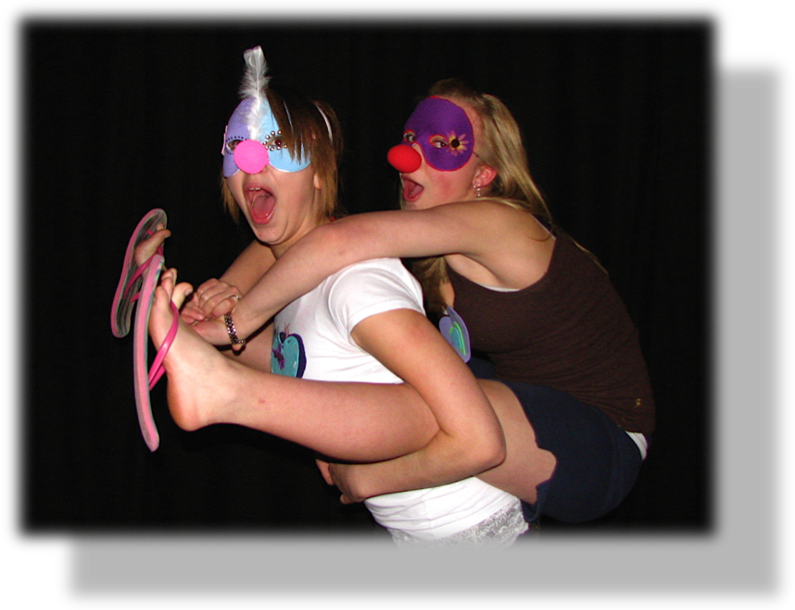

Sharing our learning with Living Sky School Division

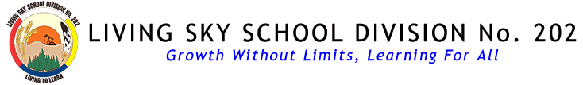
Arts & Learning
Template for Planning
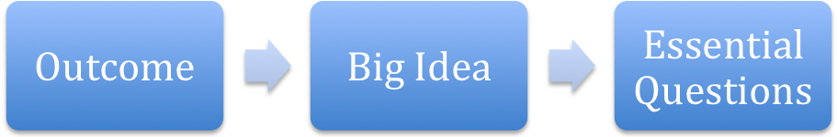
Indicators: Know/Do/Understand
Stage One:
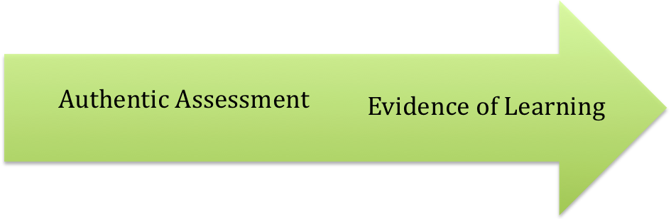
Stage Two:
Stage Three:

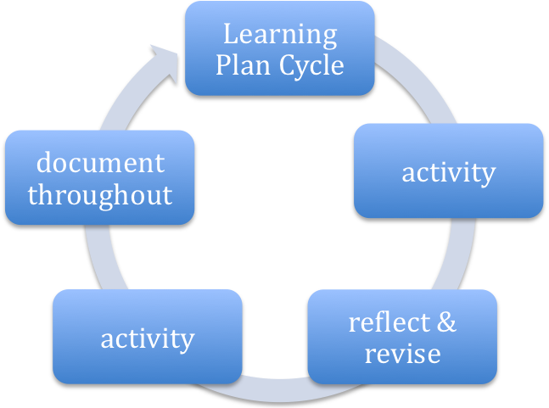

Name
School
Grade (s)
Strand(s)

Outcome (copy from the overview chart K – 9, use new curriculum)
Indicators (copy from curriculum but you can also revise/add indicators)

Big Ideas
Describe what you see as the Big Ideas and Enduring Understandings from the Outcome. You might get determine these with the help of your students or you might do it on your own.

Essential Questions
Inquiry process can help guide the learning. What questions stimulate thinking and Deeper Understanding? What questions do students have about this big idea? Know:
List what students have to know and understand in order to complete the unit. This includes vocabulary, concepts, steps in a process, group skills, etc.

Do:
List what students have actually do in the unit - the activities, exercises, practices, performance tasks, etc.

Teacher Reflection
Questions you might ask yourself as you plan:

1. Explanation: How will students be expected to support claims, conclusions, and assertions with evidence from what we are studying?

2. Interpretation: How will students be asked to construct meaning and express their conclusions through the creation of original works of art and through artistic performances?

3. Application: How will I ensure that my students move beyond formulaic modeling of the information, skills and procedures they are using toward independent understanding and original use in a creative, authentic way?

4. Perspective: How will I encourage my students to investigate, explore, and debate differing points of view associated with the topics, ideas, and processes we will study in this unit/course?

5. Empathy: How will I support my students to understand the feelings and aesthetic reactions of others? How can I encourage my students to "walk in the shoes" of others?

6. Self-Knowledge: How will my students' experiences in the visual and performing arts enhance their understanding of themselves, their aesthetic values, and their comprehension of the world in which they live?

(from John Brown, ArtsEdge “Teaching for Understanding” series based on principles of Understanding by Design)
How Will I Know They Learned?
Assessment can take many forms as it reflects the thinking, process and end product. At times, students can help determine qualities or characteristics of the evaluation. A Photo Album, (as opposed to a Snap Shot) of evidence should represent the assessment.
Formative Tools
(during the process, reveal the thinking, learning from mistakes, reflection, interviews, etc.)
Pre-Assessments

Self-Assessments

Other
Summative Tools
(at the end, performance tasks, rubrics – student input to identify characteristics, etc.)

Performance Task

Other Evidence
Learning Plan
What will you teach? Outline the activities. Keep this simple for now as it is bound to change as you teach the unit. Take note of how or why it changes – this is part of the reflective practice.

Documentation
How will you share this with others? Will you find moments to capture on video, photo, or interview?
Activities & Documentation

